MINI AUTONOMOUS CAR WITH V2V DECISION MAKING

A PROJECT REPORT

Submitted by

B TAARUN 22EE008
B DHARANI PRASAD 22EE010

in partial fulfillment for the award of the degree
of

BACHELOR OF ENGINEERING
in

ELECTRICAL AND ELECTRONICS ENGINEERING


CHENNAI INSTITUTE OF TECHNOLOGY (AUTONOMOUS)
(Affiliated to Anna University, Chennai) CHENNAI-600 069


ANNA UNIVERSITY: CHENNAI-600 025

MARCH-2026

CHENNAI INSTITUTE OF TECHNOLOGY
(An Autonomous Institution, Affiliated to Anna University, Chennai)

BONAFIDE CERTIFICATE
Certified that this project report “MINI AUTONOMOUS CARS WITH V2V DECISION MAKING ” is the Bonafide work of B TAARUN (22EE008), B DHARANI PRASAD(22EE010) who carried out the project work under my supervision.

SIGNATURE SIGNATURE

Dr.R.SANKAR M.E,Ph.D. Mr.M. EZHILMARAN M.E.
Head of Department Assisstant Professor

Department of Electrical and Electronics Engineering,
Department of Electrical and Electronics Engineering,

Chennai Institute of Technology, Chennai Institute of Technology, Chennai-600069. Chennai-600069.

Certified that the above students have attended a viva voice during the exam held on……………….......

INTERNAL EXAMINER EXTERNAL EXAMINER



Vision of the Institute:

To be an eminent centre for Academia, Industry and Research by imparting knowledge, relevant practices and inculcating human values to address global challenges through novelty and sustainability.

Mission of the Institute:

IM1.To create next generation leader by effective teaching learning methodologies and install scientific spark in them to meet the global challenges.
IM2.To transform lives through deployment of emerging technology, novelty and sustainability.
IM3.To inculcate human values and ethical principles to cater the societal needs.
IM4.To contributes towards the research ecosystem by providing a suitable, effective platform for interaction between industry, academia and R &D establishments.
IM5.To nurture incubation centres enabling structured entrepreneurship and start- ups.



Vision of the Department:

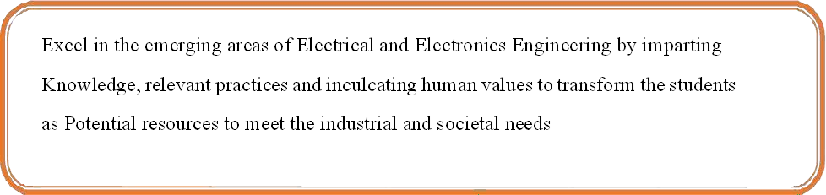

Mission of the Department:

DM1: To provide strong fundamentals and technical skills through effective teaching Learning Methodologies
DM2: To transform lives of the students by fostering ethical values, creativity and novelty to Become entrepreneurs and establish start-ups
DM3: To habituate the students to focus on sustainable resources with optimal usage to ensure the Welfare of the society.
DM4: To provide an ambience for research through collaborations with industry and academia.
DM5: To inculcate learning of emerging technologies for pursuing higher studies leading to lifelong learning.



Program Educational Objectives (PEOs):

Graduates will be able to
PEO1. Contribute to the industry as an Engineer through sound knowledge acquired In core engineering to develop new processes and implement the solutions for industrial problems.
PEO2. Establish an organization / industry as an Entrepreneur with professionalism, leadership quality, teamwork, and ethical values to meet the societal needs.
PEO3. Create a better future by pursuing higher education / research and develop the sustainable products / solutions to meet the demand.

Program Specific Outcomes (PSOs)
Graduates will be able to

S. No | Programme Specific Outcomes
PSO1 | To analyse, design and develop quality solutions in power electronics by applying the core engineering knowledge for industrial and domestic  applications.
PSO2 | To provide solutions for generating clean, safe and sustainable power  through multidisciplinary approaches

Program Outcomes with Graduate Attributes

S.  No | Graduate Attribute | Program Outcomes
1. | Engineering knowledge | Apply the knowledge of Mathematics and Science with  fundamentals of Electrical and Electronics Engineering to solve complex engineering problems.
2. | Problem analysis | Identify, formulate, review research literature, and analyze complex engineering problems related to Electrical and Electronics Engineering and reaching substantiated conclusions using first principles of Mathematics, natural sciences, and engineering  sciences.
3. | Design/Developm ent of solutions | Design solutions for complex engineering problems related to Electrical and Electronics Engineering and develop processes that meet the specified needs with appropriate consideration for the public health and safety, and the cultural,  societal, and environmental considerations.
4. | Conduct investigations of complex  problems | Use research-based knowledge and research methods including design of experiments, analysis and interpretation of data, and synthesis of the information to provide valid conclusions.
5. | Modern Tool usage | Create, select, and apply appropriate techniques, resources, and modern engineering and IT tools including prediction and modeling to Electrical and Electronics Engineering related complex engineering activities with an understanding of the  limitations.
6. | The Engineer and society | Apply reasoning informed by the contextual knowledge to assess societal, health, safety, legal and cultural issues and the consequent responsibilities relevant to the Electrical and  Electronics Engineering professional practice.
7. | Environment and sustainability | Understand the impact of the professional Electrical and Electronics Engineering solutions in societal and environmental contexts, and demonstrate the knowledge of, and need for  sustainable development.

8. | Ethics | Apply ethical principles and commit to professional ethics and  responsibilities and norms of the engineering practice.
9. | Individual and team  work | Function effectively as an individual, and as a member or leader in  diverse teams, and in multidisciplinary settings.
10. | Communication | Communicate effectively on complex engineering activities with the engineering community and with society at large, such as, being able to comprehend and write effective reports and design documentation, make effective presentations, and give and receive  clear instructions.
11. | Project  management and  finance | Demonstrate knowledge and understanding of the engineering and management principles and apply these to one’s own work, as a member and leader in a team, to manage projects and in multidisciplinary environments
12. | Life-long learning | Recognize the need for, and have the preparation and ability to engage in independent and life-long learning in the broadest  context of technological change.

Course Outcomes:

CO | Outcomes
CO1 | Ability to identify, formulate, design, interpret, analyze and provide solutions to complex  engineering and societal issues by applying knowledge gained on basics of science and Engineering.
CO2 | Ability to choose, conduct and demonstrate a sound technical knowledge of their selected project topics in the field of power components, protection, high voltage, electronics, process automation, power electronics and drives instrumentation and  control by exploring suitable engineering and IT tools.
CO3 | Ability to understand, formulate and propose new learning algorithms to solve engineering and societal problems of moderate complexity through multidisciplinary projects understanding commitment towards sustainable  development.
CO4 | Ability to demonstrate, prepare reports, communicate and work in a team as a  member/leader by adhering to ethical responsibilities.
CO5 | Ability to acknowledge the value of continuing education for oneself and to stay up with technology advancements.

Sustainable Development Goals (SDG)

SDG  Number | SDG Title | Relevance with Project
SDG 3 | Good Health and Well- being | The project directly contributes to improved patient care by enabling continuous real-time monitoring of vital parameters. This allows for timely detection of anomalies and faster medical intervention, thereby enhancing overall  health outcomes.
SDG 9 | Industry, Innovation, and Infrastructure | The project leverages innovative IoT technologies to integrate multiple sensors within a wearable glove. This approach fosters innovation in healthcare technology and strengthens the infrastructure for  remote monitoring.
SDG 11 | Sustainable Cities and Communities | By enabling remote patient monitoring, your system reduces the need for frequent hospital visits and supports smart healthcare practices. This contributes to building more resilient and sustainable communities, particularly in urban areas where healthcare resources can be  optimized.
SDG 12 | Responsible Consumption and Production | The project emphasizes an energy-efficient design through the use of low-power sensors and optimized power management strategies. This not only reduces energy consumption but also supports sustainable production practices in the development of  medical devices.

ACKNOWLEDGEMENT

We express our gratitude to our Chairman Shri.P. SRIRAM and all trust members of Chennai institute of technology for providing the facility and opportunity to do this project as a part of our undergraduate course.
We are grateful to our Principal Dr.A. RAMESH M.E, Ph.D. for providing us the facility and encouragement during the course of our work.
We sincerely thank our Head of the Department, Dr.R.SANKAR M.E,Ph.D., Department of Electrical and Electronics Engineering for having provided us valuable guidance, resources and timely suggestions throughout our work.

We sincerely thank our Project Guide, Mr.M. EZHILMARAN M.E., Professor, Department of Electrical and Electronics Engineering for having provided us with valuable guidance, resources and timely suggestions throughout our work.
We would like to extend our thanks to our Project coordinator of the Department of Electrical and Electronics Engineering, for their valuable suggestions throughout this project.

We wish to extend our sincere thanks to all Faculty members of the Department of Electrical and Electronics Engineering for their valuable suggestions and their kind cooperation for the successful completion of our project.

We wish to acknowledge the help received from the Lab Instructors of the Department of Electrical and Electronics Engineering and others for providing valuable suggestions and for the successful completion of the project.

ABSTRACT

Advancements in embedded systems, wireless communication, and autonomous technologies are transforming modern transportation systems. One of the major challenges in road safety occurs at intersections, where vehicles approach from different directions with limited coordination, often leading to collisions due to delayed human reactions, poor visibility, or lack of traffic control infrastructure. Traditional traffic management systems such as traffic signals and manual control rely heavily on centralized infrastructure and human compliance, which may not always ensure safe and efficient traffic flow.

This project presents the design and development of a low-cost miniature autonomous vehicle system with Vehicle-to-Vehicle (V2V) communication capable of intelligent decision-making at road intersections. The system consists of two miniature autonomous vehicles developed using embedded system technologies. Each vehicle is equipped with an ESp-32 microcontroller, ultrasonic sensors, DC motors with motor drivers, and wireless communication modules. The sensors detect nearby vehicles and intersection ones, while the wireless module enables real- time communication between vehicles to exchange information such as vehicle ID, distance, and movement status.

To further validate the system, a digital simulation environment using VEINS (OMNeT++ integrated with SUMO) was used to model traffic behavior and wireless communication between vehicles. The experimental results demonstrate that the proposed system successfully enables autonomous negotiation and collision-free intersection crossing through cooperative communication and real-time decision making. This project highlights how intelligent transportation concepts can be implemented using affordable embedded hardware and simple algorithms, providing a practical platform for research in autonomous systems and smart mobility technologies.

TABLE OF CONTENTS

CHAPTER |  | TITLE | PAGE NO
NO.
 |  | ABSTRACT | xi
 |  | LIST OF TABLES | xiv
 |  | LIST OF FIGURES | xiv
 |  | LIST OF SYMBOLS | xv
1. |  | INTRODUCTION | 1
 | 1.1 | Background of the Study | 2
 | 1.2 | Problem Statement | 2
 | 1.3 | Motivation | 2
 | 1.4 | Objective | 3
 | 1.5 | Scope of the Study | 3
2. |  | LITERATURE REVIEW | 4
 | 2.1 | Autonomous Vehicles and Intelligent Transportation Systems | 4
 | 2.2 | Vehicle-to-Vehicle Communication Technologies | 4
 | 2.3 | Embedded Systems for Autonomous | 5
 |  | Vehicles
 | 2.4 | Related Implementations | 6
3. |  | METHODOLOGY | 7
 | 3.1 | System Overview | 8
 | 3.2 | Hardware Design Development | 8
 | 3.3 | Sensor Integration | 9
 | 3.4 | Wireless Communication Implementation | 11
 | 3.5 | Implementation Flow | 11
 | 3.6 | Decision-Making Algorithm | 12
 | 3.7 | Performance Evaluation | 12
4. |  | Architecture and Design | 13
 | 4.1 | Overall Architecture | 13

4.2

Sensor and Communication 14
4.3 Vehicle Control System 14
4.4 Implementation Notes (Embedded System 16
Flow)
- Software and Algorithm Implementation 17
Microcontroller Programming
  - V2V Communication Protocol 17
  - Collision Avoidance Algorithm 18
5.3 System Integration 18
  - Experimental Setup 18
5.5 Integration with Hardware 19
5.6 Observation 19
- VERIFICATION AND TESTING 21
6.1 Hardware Testing methodology 21
6.2 Communication Testing 21
6.3 Vehicle Coordination Testing 22
6.4 Simulation Validation 22
7 RESULTS 23
  - Experimental Setup 23
  - System Performance 24
  - Collision Avoidance Performance 24
  - Work Efficiency 25
7.5 Result Summary 25
- DISCUSSION 29
  - Interpretation of Results 29
  - Significance 30
  - Comparison with Baseline 30
  - Practical Relevance 31
  - Limitations 31
  - Future Work Recommendations 31
- CONCLUSION 32
  - Key Outcomes 32
  - Advantages 32
  - Future Scope 32
  - Concluding Remarks 32

APPENDIX 34
REFERENCES 36
PO& PSO 39

LIST OF TABLES

TABLE NO. | TABLE NAME | PAGE NO.
3.1 | System Hardware Components | 08
3.2 | Sensor Specifications | 10
5.1 | Vehicle Communication Data Structure | 16
7.1 System Performance Evaluation
22

LIST OF FIGURES

FIGURE NO. FIGURE NAME PAGE NO.
Mini Autonomous Vehicle
3.1
Prototype 11

  - Wireless Communication Setup 19

Vehicle-to-Vehicle Communication
4.3
Model 26

  - Collision Avoidance Demonstration 43

7.5 Project Photos 45
7.6 Simulation Results 46

LIST OF SYMBOLS, ABBREVIATIONS AND NOMENCLATURE

SYMBOLS
Symbol | Description
$$\left(V_{i}\right)$$ | Vehicle (i) in the autonomous vehicle system
$$\left(V_{j}\right)$$ | Neighboring vehicle involved in communication
$$\left(D_{i}\right)$$ | Distance of vehicle (i) from the intersection
$$\left(D_{s}\right)$$ | Distance measured by ultrasonic sensor
$$\left(S_{i}\right)$$ | Speed of vehicle (i)
$$\left(ID\right)$$ | Unique identification number of a vehicle
$$\left(T_{d}\right)$$ | Decision time taken by the system
$$\left(P_{i}\right)$$ | Priority assigned to vehicle (i)
$$\left(Z\right)$$ | Intersection decision zone
$$\left(R_{c}\right)$$ | Communication range between vehicles
$$\left(C_{msg}\right)$$ | Communication message exchanged between vehicles
$$\left(T_{cycle}\right)$$ | System decision cycle time
$$\left(GO\right)$$ | Command indicating the vehicle can proceed
$$\left(WAIT\right)$$ | Command indicating the vehicle must stop
$$\left(V_{cc}\right)$$ | Supply voltage of the embedded system
$$\left(I_{total}\right)$$ | Total current consumption of the system
$$\left(P_{total}\right)$$ | Total power consumption of the system
$$\left(f_{clk}\right)$$ | Microcontroller clock frequency
$$\left(t_{delay}\right)$$ | System response delay
$$\left(d_{safe}\right)$$ | Safe distance maintained between vehicles
$$\left(N_{v}\right)$$ | Number of vehicles in the system

ABBREVIATIONS

Abbreviation Expanded Form
V2V Vehicle-to-Vehicle Communication
ITS Intelligent Transportation System
MCU Microcontroller Unit
IR Infrared Sensor
DC Direct Current
PWM Pulse Width Modulation
UART Universal Asynchronous Receiver Transmitter
I2C Inter-Integrated Circuit Communication
SPI Serial Peripheral Interface
GPI General Purpose Input Output
IOT Internet Of Things
BLE Bluetooth Low Energy

NOMENCLATURE

Term Definition

Autonomous Vehicle
ESP32
Controller
Vehicle-to- Vehicle Communication
Decision Algorithm
Vehicle that moves without human control using sensors and a controller
Microcontroller used for vehicle control and Bluetooth communication
Data exchange between vehicles using Bluetooth

Logic used to decide vehicle movement (go or slow down)

Safe Distance Minimum distance maintained between vehicles

Ultrasonic Sensor
Bluetooth Module
Intersection Zone
Sensor used to measure distance to nearby vehicles or obstacles
Wireless interface in ESP32 used for communication between cars
Area where vehicles from different directions meet

Vehicle Priority Rule used to decide which vehicle moves first
Control Signal Command sent from ESP32 to control vehicle
movement

Collision Avoidance
Method used to prevent vehicles from crashing

CHAPTER:1

INTRODUCTION

The rapid growth of intelligent transportation technologies has created opportunities to improve road safety and traffic efficiency through automation and communication between vehicles. Traditional transportation systems rely heavily on human drivers to make decisions while driving. However, human errors such as delayed reaction time, lack of situational awareness, and poor judgment are major causes of road accidents. As a result, researchers and engineers are increasingly exploring autonomous systems and cooperative vehicle technologies that can assist or replace human decision-making in certain driving situations. Autonomous vehicles represent a major advancement in modern transportation systems. These vehicles are capable of sensing their environment, communicating with other vehicles, and making real-time decisions based on available data. One of the key concepts enabling this technology is Vehicle-to-Vehicle (V2V) communication, where vehicles exchange information such as speed, position, and direction. By sharing this information, vehicles can coordinate their movement and avoid potential collisions[3,4].

This project focuses on developing a mini autonomous car system with V2V decision making using embedded system technology. The system uses an ESP32 microcontroller, which includes a built-in Bluetooth communication module. The ESP32 enables vehicles to exchange information wirelessly and make cooperative decisions. Each vehicle is equipped with sensors to detect nearby vehicles or obstacles, while a motor driver module controls the movement of the vehicle.[5] In each case, the vehicles communicate and apply a simple decision algorithm to avoid collisions and maintain safe movement.The project highlights how low-cost embedded systems and wireless communication can be used to implement fundamental concepts of intelligent transportation systems. By combining sensing, communication, and decision-making, the system provides a practical demonstration

Background of the Study
Transportation systems are evolving with the integration of embedded systems, wireless communication technologies, and intelligent control algorithms. Autonomous vehicle technology aims to reduce accidents, improve traffic flow, and enhance overall transportation efficiency. One of the important components of autonomous vehicle systems is the ability of vehicles to communicate with each other in real time.

Vehicle-to-Vehicle communication allows vehicles to exchange information such as location, speed, and driving intentions. This communication enables vehicles to make cooperative decisions, especially in situations where collision risks are high. In recent years, microcontrollers with integrated wireless capabilities, such as the ESP32, have made it possible to develop small-scale prototypes that demonstrate these concepts.

Problem Statement

Road accidents frequently occur due to lack of coordination between vehicles, especially in situations where vehicles approach each other from different directions or when one vehicle follows another too closely. Human drivers may fail to react quickly enough to avoid collisions. This lack of communication can lead to dangerous situations such as head-on collisions, rear-end collisions, or intersection crashes.

Motivation

The motivation behind this project is to explore how simple embedded systems and wireless communication can be used to implement cooperative vehicle behavior. By enabling vehicles to exchange information and make basic decisions automatically, it is possible to improve safety and reduce the chances of accidents. Using an ESP32

microcontroller with built-in Bluetooth communication provides a cost-effective platform for demonstrating Vehicle-to-Vehicle communication. The project also aims to create a practical model that illustrates how autonomous vehicles can detect nearby vehicles, communicate their presence, and adjust their movement accordingly.

Objective of the Work
The main objectives of this project are:
- To design and develop a mini autonomous vehicle system using the ESP32 microcontroller.
- To implement Bluetooth-based Vehicle-to-Vehicle communication between vehicles.
- To develop a decision algorithm that enables vehicles to coordinate their movement.
- To control vehicle motion using a motor driver module.
- To demonstrate collision avoidance in three test scenarios: opposite direction movement, same direction movement, and perpendicular intersection movement.

Scope of the Study

This project focuses on developing a prototype autonomous vehicle system capable of basic communication and decision-making. The system demonstrates how vehicles can exchange information using Bluetooth and coordinate their movement using embedded algorithms.[7]

The project is limited to small-scale autonomous vehicle models controlled by ESP32 microcontrollers. The results provide a foundation for further research and development in intelligent transportation systems and cooperative autonomous vehicle technologies.

CHAPTER:2
LITERATURE REVIEW

The development of autonomous vehicles and intelligent transportation systems has attracted significant attention from researchers and engineers in recent years. Advances in embedded systems, wireless communication, and sensor technologies have enabled vehicles to communicate with each other and make cooperative decisions to improve road safety. Vehicle-to-Vehicle (V2V) communication plays a crucial role in enabling autonomous vehicles to exchange information such as speed, position, and driving intentions. This chapter reviews relevant research works related to autonomous vehicles, V2V communication technologies, embedded system platforms, and collision avoidance systems.[2,8]

Autonomous Vehicles and Intelligent Transportation Systems
Autonomous vehicles are designed to operate with minimal or no human intervention by sensing the surrounding environment and making real-time decisions. These systems combine sensors, communication modules, and embedded controllers to ensure safe navigation. Intelligent Transportation Systems (ITS) integrate advanced technologies into transportation infrastructure and vehicles to improve traffic efficiency and safety.[30]

Research in autonomous vehicles focuses on enabling vehicles to detect obstacles, communicate with other vehicles, and make intelligent decisions to avoid collisions. Various technologies such as radar, cameras, LiDAR, and ultrasonic sensors are commonly used to detect nearby vehicles and obstacles. Therefore, low-cost embedded platforms combined with simple sensors have become popular for educational and experimental purposes.[29,2]

Vehicle-to-Vehicle Communication Technologies

Vehicle-to-Vehicle communication enables vehicles to exchange informationdirectly without relying on centralized infrastructure. Through V2V communication, vehicles can share data such as position, speed, and direction, allowing them to coordinate movement and reduce the risk of accidents.

Several wireless technologies have been used for V2V communication, including Dedicated Short Range Communication (DSRC), Wi-Fi, Zigbee, and Bluetooth.The ESP32 includes integrated Bluetooth and Wi-Fi modules, making it an ideal platform for implementing V2V communication in embedded systems. By using Bluetooth communication, vehicles can transmit and receive information about their movement and adjust their behavior accordingly.

Embedded Systems for Autonomous Vehicles
Embedded systems play a critical role in autonomous vehicle operation by processing sensor data and controlling vehicle movement. A microcontroller acts as the central processing unit that collects data from sensors, runs decision algorithms, and sends control signals to actuators such as motors.

Modern embedded platforms such as the ESP32 provide powerful processing capabilities along with integrated communication features.Motor driver modules are commonly used in embedded systems to control the direction and speed of DC motors. By using Pulse Width Modulation (PWM) signals generated by the microcontroller, the motor driver can regulate vehicle speed and movement.[9] The combination of sensors, microcontroller processing, and motor control enables the vehicle to respond dynamically to changes in its environment.[11,18]

Related Implementations

Several research projects and experimental prototypes have been developed to demonstrate autonomous vehicle communication and collision avoidance systems. Many of these systems focus on scenarios such as vehicles approaching from opposite directions, vehicles following each other in the same lane, and vehicles arriving at intersections simultaneously.

In some implementations, sensors are used to detect obstacles while wireless communication modules allow vehicles to exchange information about their movement. Based on this information, vehicles can apply simple decision algorithms to determine whether to move, slow down, or stop.[11,23]

Small-scale autonomous vehicle models are commonly used in academic research to study cooperative vehicle behavior. These models provide a practical platform for testing communication protocols and decision-making algorithms in controlled environments. By analyzing different traffic scenarios, researchers can evaluate the effectiveness of collision avoidance strategies and improve the reliability of autonomous vehicle systems.[8,17]

CHAPTER 3 METHODOLOGY

This chapter explains the design and implementation approach used to develop the mini autonomous vehicle system with Vehicle-to-Vehicle communication. The methodology focuses on integrating embedded hardware, wireless communication, and a decision-making algorithm to enable vehicles to coordinate their movement and avoid collisions.[25,3] The system uses an ESP32 microcontroller with built-in Bluetooth communication to allow vehicles to exchange information and make cooperative decisions in real time.

The development process includes hardware design, communication setup, algorithm implementation, and testing under different vehicle interaction scenarios.

System Overview

The proposed system consists of miniature autonomous vehicles controlled by an ESP32 microcontroller. Each vehicle is equipped with sensors to detect nearby vehicles or obstacles and a motor driver module to control the movement of the vehicle. The vehicles continuously exchange information regarding their movement and position. 19,33]

The overall system consists of four main components:
    - Sensing Unit – Detects nearby vehicles or obstacles.
    - Communication Unit – Exchanges information between vehicles using Bluetooth.
    - Decision-Making Unit – Processes data and determines vehicle behavior.
    - Control Unit – Controls motor movement through the motor driver module.

Table 3.1: System Hardware Components
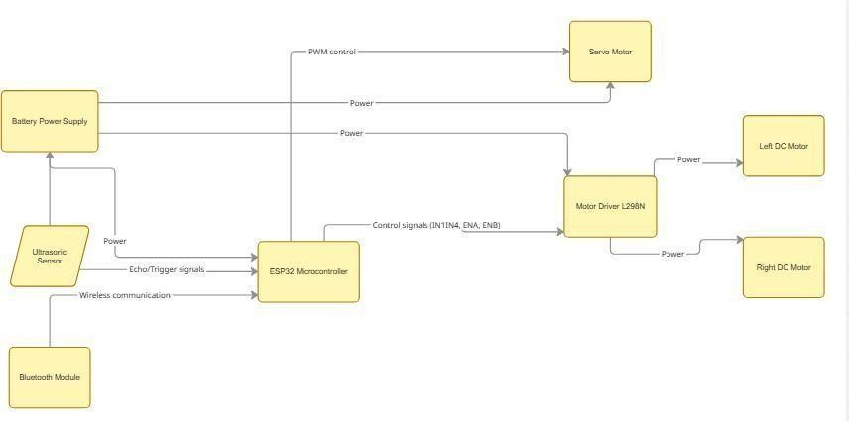
S. No | Component | Quantity | Description
1 | ESP32 Microcontroller | 1 | Main controller responsible for processingsensor data and Bluetooth  communication
2 | Ultrasonic Sensor (HC- SR04) | 1 | Measures distance between vehicles and detects nearby obstacles
3 | Motor Driver Module (L298N) | 1 | Controls direction and speed of DC motors
4 | DC Gear Motors | 2 | Provides movement to the autonomous vehicle
5 | Servo Motor (SG90) | 1 | Rotates the ultrasonic sensor for scanning nearby areas
6 | Chassis with Wheels | 1 | Mechanical structure of the vehicle
7 | Battery Pack | 1 | Power supply for ESP32, sensors, and motors
8 | Bluetooth Module (Built-in ESP32) | 1 | Enables wireless communication between vehicles
Figure 3.1 : Mini Autonomous Vehicle Prototype

Hardware Design Development
The hardware architecture of the system is designed using compact embedded components that enable sensing, communication, and vehicle movement control. The main hardware components used in the system include:
ESP32 Microcontroller – Acts as the central controller of the vehicle. It processes sensor inputs, manages Bluetooth communication, and executes the decision algorithm.
- Ultrasonic Sensor – Used to measure the distance between vehicles and detect nearby obstacles.
- Motor Driver Module – Controls the direction and speed of the DC motors that drive the vehicle.
- DC Motors – Provide motion for the autonomous vehicle.
- Power Supply – Provides the required voltage to operate the microcontroller and motors.

The ESP32 microcontroller receives sensor data, communicates with other vehicles through Bluetooth, and sends control signals to the motor driver module to regulate vehicle movement.

Table 3.2: Sensor Specifications
Parameter | Ultrasonic Sensor (HC-SR04)
Operating Voltage | 5V
Operating Current | 15 mA
Measuring Range | 2 cm – 400 cm
Measuring Angle | 15°
Accuracy | ±3 mm
Trigger Input Signal | 10 µs TTL Pulse
Echo Output Signal | Pulse Width proportional to distance

Sensor Integration

Sensors play an important role in detecting the surrounding environment of the vehicle. In this project, ultrasonic sensors are used to measure the distance between vehicles and detect nearby obstacles.[31,28] The ultrasonic sensor works by transmitting sound waves and measuring the time taken for the echo to return. Based on this time delay, the distance between the vehicle and an object can be calculated.

The sensor continuously monitors the environment and sends distance information to the ESP32 microcontroller. If the detected distance falls below a predefined safe threshold, the controller adjusts the vehicle's movement to maintain safe spacing between vehicles.

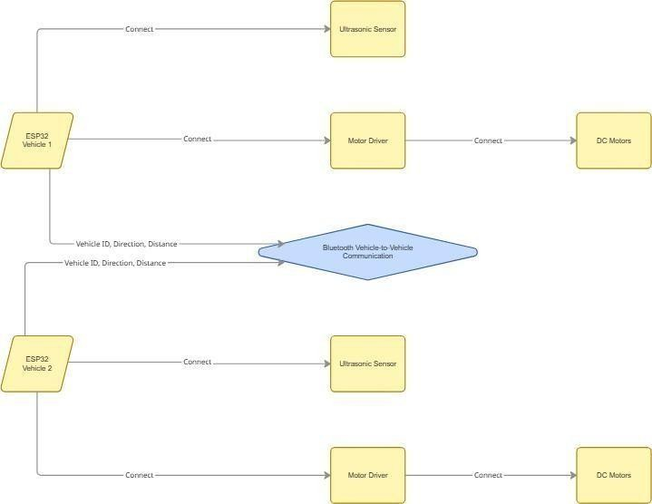

Figure 3.2: Wireless Communication Setup

Wireless Communication Implementation

Wireless communication between vehicles is implemented using the Bluetooth capability of the ESP32 microcontroller. The ESP32 has an integrated Bluetooth module that allows vehicles to transmit and receive information without additional hardware.
Each vehicle broadcasts information such as:
- Vehicle identification number
- Distance from nearby vehicles
- Movement status (moving or stopped)
This information is received by neighboring vehicles through Bluetooth communication. The communication process occurs continuously, ensuring that vehicles always have updated information about nearby vehicles. Using Bluetooth communication simplifies the system design and enables reliable data exchange between vehicles in short-range environments.[14,22]

Implementation Flow

The implementation of the system follows a step-by-step process to ensure reliable operation.
- The ESP32 microcontroller initializes all sensors and communication modules.
- The ultrasonic sensor measures the distance to nearby vehicles or obstacles.
- The ESP32 transmits its current status to other vehicles using Bluetooth.
- Each vehicle receives information from neighboring vehicles.
- The decision algorithm analyzes sensor data and received communication data.
- Based on the analysis, the vehicle determines whether to move, slow down, or stop.
- Control signals are sent to the motor driver module to adjust vehicle movement.
- This process repeats continuously during vehicle operation.

Decision-Making Algorithm
    - The decision-making algorithm is responsible for determining how each vehicle should behave based on sensor data and communication information. The algorithm uses simple rule-based logic to ensure safe vehicle movement.
    - If another vehicle is detected within the safe distance range, the vehicle slows down or stops.
    - If no obstacle or vehicle is detected within the safety range, the vehicle continues moving forward.
    - When multiple vehicles approach the same area, priority rules determine which vehicle moves first.
    - This rule-based approach ensures predictable system behavior and reduces the risk of collisions.

Performance Evaluation
The system was evaluated through practical testing using three main scenarios that simulate common traffic situations.

A).Scenario 1 – Opposite Direction Movement
Two vehicles approach each other from opposite directions. The system ensures that the vehicles maintain a safe distance and avoid collision.

B).Scenario 2 – Same Direction Movement
One vehicle follows another vehicle moving in the same direction. The following vehicle adjusts its speed based on the distance to the leading vehicle.

C).Scenario 3 – Intersection Movement
Two vehicles approach an intersection from perpendicular directions. The system determines vehicle priority and allows one vehicle to proceed while the other waits. These test cases demonstrate the effectiveness of the system in enabling cooperative vehicle behavior and collision avoidance.

CHAPTER 4 ARCHITECTURE AND DESIGN

This chapter explains the structural design and operational architecture of the proposed autonomous vehicle system. The architecture integrates sensing, communication, decision-making, and motion control components into a single embedded system. The design focuses on enabling vehicles to detect nearby vehicles, exchange information through wireless communication, and make cooperative decisions to avoid collisions.

The system architecture is built around the ESP32 microcontroller, which acts as the central control unit. The ESP32 processes sensor inputs, communicates with nearby vehicles through Bluetooth, and generates control signals to regulate vehicle movement through the motor driver module.

Overall Architecture
The overall architecture of the system consists of four main modules:
        - Sensing Module
        - Communication Module
        - Decision-Making Module
        - Control and Actuation Module
The sensing module detects nearby vehicles or obstacles using ultrasonic sensors. These sensors continuously monitor the distance between vehicles and provide real- time information to the microcontroller. The communication module uses the built-in Bluetooth capability of the ESP32 to enable Vehicle-to-Vehicle communication. Vehicles exchange information such as vehicle identification, distance measurements, and movement status.The decision-making module processes both sensor data and received communication data. Based on predefined decision rules,

the system determines the appropriate action for the vehicle, such as continuing movement, slowing down, or stopping. The control and actuation module executes the decision by controlling the motor driver module. This modular architecture allows the system to operate reliably while maintaining flexibility for future improvements.
.

Sensor And Communication Architecture

The sensor and communication architecture forms the perception and interaction layer of the system. Sensors are responsible for detecting the physical environment, while the communication module allows vehicles to share information with each other. The ultrasonic sensor measures the distance between the vehicle and nearby objects. The sensor transmits ultrasonic waves and measures the time taken for the echo to return. The ESP32 calculates the distance based on this time delay and determines whether another vehicle is within the safe range.

The Bluetooth communication system enables vehicles to exchange information wirelessly. Each ESP32 periodically broadcasts data that includes the vehicle ID and movement status. Other vehicles receive this information and update their internal system state accordingly. By combining sensor data and communication data, the system achieves a more reliable understanding of the surrounding environment.[19,20]

Vehicle Control System
The vehicle control system manages the physical movement of the autonomous vehicle. The control system includes the ESP32 microcontroller, motor driver module, and DC motors.

The motor driver module acts as an interface between the microcontroller and the motors. Since the ESP32 cannot supply enough current to drive motors directly, the motor driver amplifies control signals and provides the required power to the motors.

The ESP32 generates Pulse Width Modulation (PWM) signals that control the speed of the motors. By adjusting the duty cycle of the PWM signal, the system can regulate the speed of the vehicle.

Based on the decision-making algorithm, the ESP32 sends control commands to the motor driver to perform actions such as:
- Move forward
- Slow down
- Stop the vehicle
This control mechanism ensures smooth and stable vehicle movement.

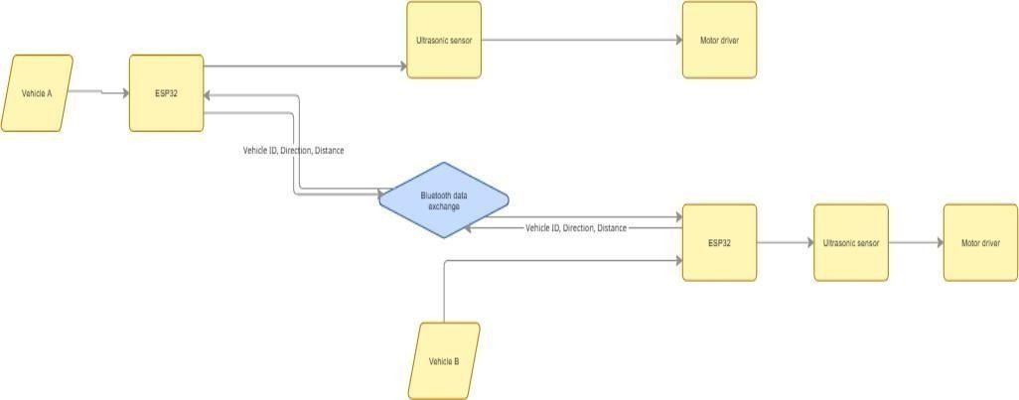

Figure 4.3: Vehicle-to-Vehicle Communication Model

Implementation Notes (Embedded System Flow)

The implementation of the system follows a structured embedded system workflow. First, the ESP32 initializes all hardware components, including sensors and communication modules. Once the system starts operating, the ultrasonic sensor continuously measures the distance to nearby vehicles or obstacles. At the same time, the ESP32 sends and receives Bluetooth messages from other vehicles. These messages provide information about the presence and movement of neighboring vehicles. The microcontroller processes both sensor data and communication data using the decision algorithm. Based on the results of this analysis, the system determines the appropriate action for the vehicle.[15,35]

Finally, control signals are sent to the motor driver module to execute the decision. This process runs continuously in a loop, allowing the vehicle to react dynamically to changes in its environment. This architecture demonstrates how sensing, communication, and control can be integrated into a cooperative autonomous vehicle system.

CHAPTER 5
SOFTWARE AND ALGORITHM IMPLEMENTATION

This chapter describes the software design and algorithm used to control the autonomous vehicle system. The software is responsible for managing communication between vehicles, processing sensor data, and controlling vehicle movement. The program is implemented using the ESP32 microcontroller, which integrates sensing, communication, and control functions within a single embedded platform. The program controls the operation of sensors, manages Bluetooth communication between vehicles, and executes the decision-making algorithm that determines vehicle behavior.[17,29]

5.1 Microcontroller Programming
The ESP32 microcontroller acts as the central processing unit of the system. It receives input from sensors, processes communication data from other vehicles, and generates control signals for the motor driver module.
The main control loop of the program performs the following tasks:
- Read sensor data from the ultrasonic sensor
- Send vehicle status information using Bluetooth communication.
- Receive communication data from other vehicles.
- Execute the decision-making algorithm.
- Control the vehicle movement through the motor driver.
This continuous cycle allows the system to respond dynamically to changes in the surrounding environment.

Field | Description | Example Value
Vehicle ID | Unique identifier assigned to each vehicle | 1
Direction | Current movement direction of vehicle | F (Forward)
Distance | Distance measured by ultrasonic sensor | 18 cm
Status | Current vehicle action | Moving / Stop
Table 5.1: Vehicle Communication Data Structure

5.2 V2V Communication Protocol
Vehicle-to-Vehicle communication is implemented using the Bluetooth capability of the ESP32 microcontroller. Each vehicle broadcasts its presence and movement status to nearby vehicles.
The communication data transmitted between vehicles includes:
- Vehicle identification number
- Distance information from sensors
- Current movement status
Bluetooth communication allows vehicles to exchange information in real time. This data helps vehicles understand the presence and behavior of other vehicles in the system. The communication protocol ensures that vehicles continuously update their status and receive updates from neighboring vehicles, enabling cooperative decision- making.[1,2]

Collision Avoidance Algorithm
The collision avoidance algorithm is designed to prevent vehicles from colliding by controlling their movement based on sensor readings and communication data. The algorithm follows simple rule-based logic to determine vehicle behavior. When the system detects another vehicle within a predefined safe distance, the vehicle slows down or stops. If the path is clear, the vehicle continues moving forward.

The algorithm evaluates the environment continuously and ensures that vehicles maintain a safe distance from each other. By combining sensor detection and communication information, the system improves decision accuracy. The decision logic ensures that vehicles do not move into potentially dangerous situations, thereby reducing the risk of collisions.[4,13]

System Integration

The complete system integrates hardware components with the software algorithm to create a functional autonomous vehicle platform. The ESP32 microcontroller serves as the central hub connecting sensors, communication modules, and motor drivers. Sensor data provides environmental awareness, while Bluetooth communication enables interaction between vehicles. This integration of sensing, communication, and control allows the system to operate as a cooperative
autonomous vehicle network.

Experimental Setup
The experimental setup consists of miniature vehicles equipped with ESP32 controllers, ultrasonic sensors, and motor driver modules. Each vehicle operates independently but communicates with other vehicles using Bluetooth. The vehicles are placed in controlled environments to simulate different traffic scenarios. During the experiments, vehicles exchange information and apply the decision algorithm to coordinate their movement.[16,19]

Integration with Hardware
The ESP32 microcontroller integrates sensors, Bluetooth communication, and the motor driver module. Sensor data and Bluetooth messages are processed by the ESP32 to determine vehicle movement. Based on the decision algorithm, control signals are sent to the motor driver to move, slow down, or stop the vehicle. This integration enables
This integration enables coordinated autonomous operation.

Observation

The system was tested under different scenarios to observe vehicle behaviour and evaluate system performance. The vehicles successfully communicated with each other and adjusted their movement based on the received information. The observations show that the vehicles maintained safe distances and avoided collisions in all tested scenarios. The Bluetooth communication provided reliable data exchange between vehicles, and the decision algorithm effectively controlled vehicle movement.

The results confirm that the proposed system can demonstrate basic autonomous vehicle coordination using embedded systems and wireless communication.

CHAPTER 6 VERIFICATION AND TESTING

Verification and testing are important steps in ensuring that the developed autonomous vehicle system functions correctly and safely. This chapter describes the testing procedures used to evaluate the performance of the system. The tests were conducted to verify hardware functionality, communication reliability, and the effectiveness of the decision-making algorithm.

The system was tested under controlled conditions using miniature vehicles equipped with ESP32 controllers, sensors, and motor driver modules. The testing process focused on verifying that the vehicles could communicate with each other, detect nearby vehicles, and make correct movement decisions to avoid collisions.

Hardware Testing methodology

The first stage of testing involved verifying the correct operation of the hardware components used in the system. The ESP32 microcontroller was tested to ensure proper power supply and program execution. The ultrasonic sensors were tested to confirm that they could accurately measure distance between vehicles. [35]

Communication Testing

Communication testing was performed to verify the reliability of Bluetooth communication between vehicles. Each vehicle was programmed with a unique identification and configured to transmit and receive data through the ESP32 Bluetooth module. The tests confirmed that Bluetooth communication provided stable and reliable data exchange within the operating range of the vehicles.[4,5]

Vehicle Coordination Testing

Vehicle coordination testing was conducted to verify that the decision-making algorithm correctly controlled vehicle movement. The vehicles were placed in different positions and allowed to communicate with each other through Bluetooth. The system monitored the sensor readings and communication messages to determine the appropriate action for each vehicle. [9,27]

Based on the algorithm, the vehicles adjusted their movement to maintain safe distance and avoid collisions. The tests confirmed that the vehicles were able to coordinate their actions effectively and respond correctly to different situations.

Test Case Validation
The system was validated using three main test scenarios that represent common vehicle interaction situations.

Test-Case 1 Opposite Direction Movement
Two vehicles approach each other from opposite directions. The system detects the approaching vehicle and ensures that both vehicles maintain a safe distance to prevent collision.

Test-Case 2 Same Direction Movement
One vehicle follows another vehicle moving in the same direction. The following vehicle detects the vehicle ahead and reduces speed to maintain safe spacing.

Test-Case 3 Intersection Scenario
Two vehicles approach an intersection from perpendicular directions. Using communication and sensor data, the system determines which vehicle should proceed first while the other vehicle waits. The results of these tests demonstrate that the proposed system successfully performs cooperative decision-making and collision avoidance.[3]

CHAPTER 7
RESULTS
This chapter presents the results obtained from testing the autonomous vehicle system developed in this project. The experiments were conducted using miniature vehicles equipped with ESP32 microcontrollers, ultrasonic sensors, Bluetooth communication, and motor driver modules. The purpose of the experiments was to evaluate the effectiveness of the Vehicle-to-Vehicle communication system and the decision-making algorithm in preventing collisions.

The system was tested under different vehicle interaction scenarios to observe how the vehicles communicated and coordinated their movement. The results demonstrate that the proposed system successfully enables vehicles to exchange information and make cooperative decisions in real time.[28,16]

Experimental Setup
The experimental setup consisted of miniature autonomous vehicles placed in a controlled environment to simulate different traffic situations. Each vehicle was powered by an ESP32 microcontroller that handled sensor input, Bluetooth communication, and motor control.
Table 7.1: System Performance Evaluation Results
Test Case | Scenario Description | System Response | Result
Test Case 1 | Vehicles approaching from opposite directions | Both vehicles detect each other and stop | Collision avoided
Test Case 2 | Vehicles moving in the same direction | Rear vehicle detects front vehicle and slows down | Safe distance maintained
Test Case 3 | Vehicles approaching intersection from  perpendicular directions | Vehicle with lower ID moves first | Coordinated movement achieved

7.2 System Performance

The system demonstrated stable operation during testing. The ESP32 microcontroller successfully processed sensor data and communication messages while controlling the movement of the vehicles through the motor driver module. Bluetooth communication between vehicles remained consistent within the operating range, enabling reliable data exchange.

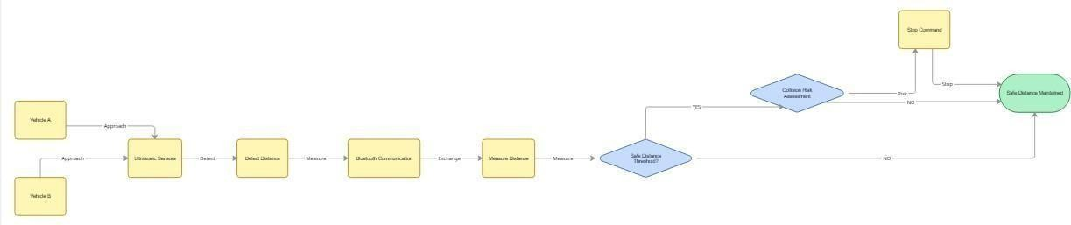
Figure 7.2: Collision Avoidance Demonstration

7.3 Collision Avoidance Performance

The collision avoidance capability of the system was evaluated using three test cases.

Test Case 1 – Opposite Direction Movement
When two vehicles approached each other from opposite directions, the system detected the presence of the other vehicle and adjusted movement to avoid collision.

Test Case 2 – Same Direction Movement
When one vehicle followed another vehicle moving in the same direction, the following vehicle detected the leading vehicle and reduced its speed to maintain a safe distance.

Test Case 3 – Intersection Scenario
When vehicles approached an intersection from perpendicular directions, the system determined vehicle priority and allowed one vehicle to proceed while the other vehicle waited.
.

Work Efficiency

The developed system demonstrated efficient performance during testing. The ESP32 microcontroller successfully processed sensor data and Bluetooth communication simultaneously without delays. The vehicles were able to detect nearby vehicles, exchange information, and respond quickly according to the decision algorithm. The system maintained safe distances and prevented collisions in all three tested scenarios. Overall, the integration of sensing, communication, and control ensured smooth and reliable operation of the autonomous vehicle system.[12,25]

Result Summary
The experimental results confirm that the proposed system successfully integrates sensing, communication, and control to achieve cooperative vehicle behaviour. The ESP32 microcontroller efficiently handled sensor processing and Bluetooth communication, while the decision algorithm ensured safe vehicle movement.The system performed reliably in all tested scenarios, maintaining safe distances between vehicles and preventing collisions. These results demonstrate the feasibility of implementing autonomous vehicle coordination using low-cost embedded systems and wireless communication technology

Project Photos:
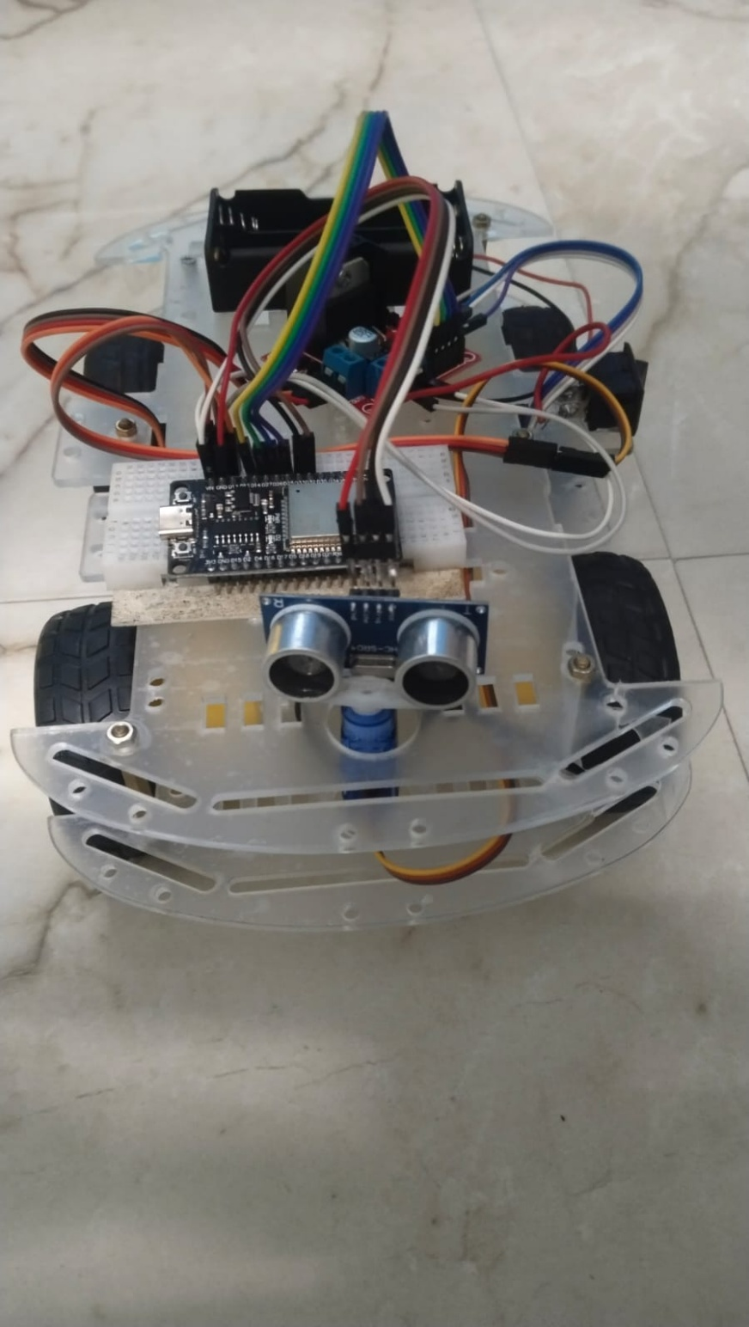

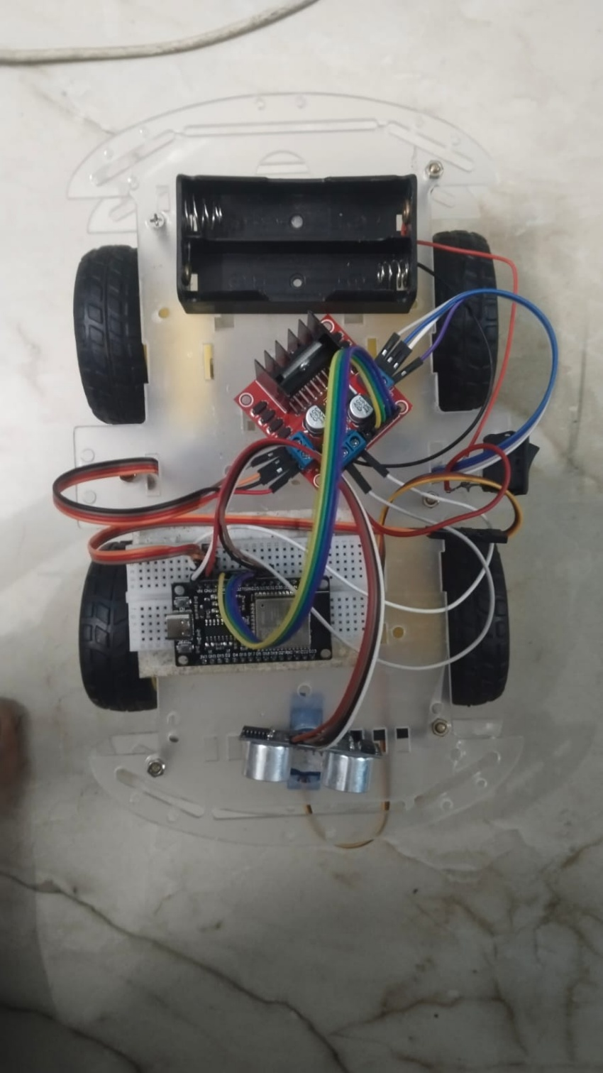

7.7 Simulation Results:

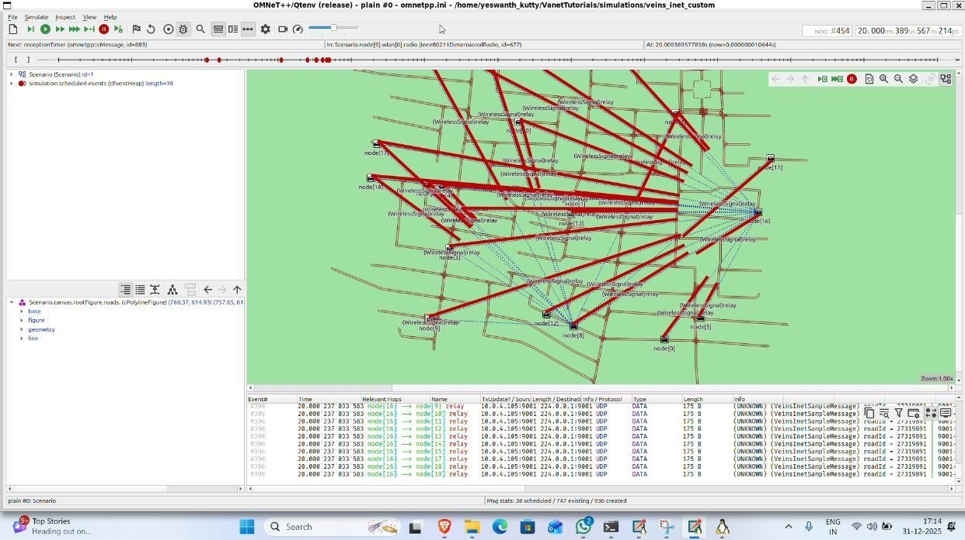

Fig 7.7.1: VEINS simulation environment showing V2V communication and intersection negotiation.

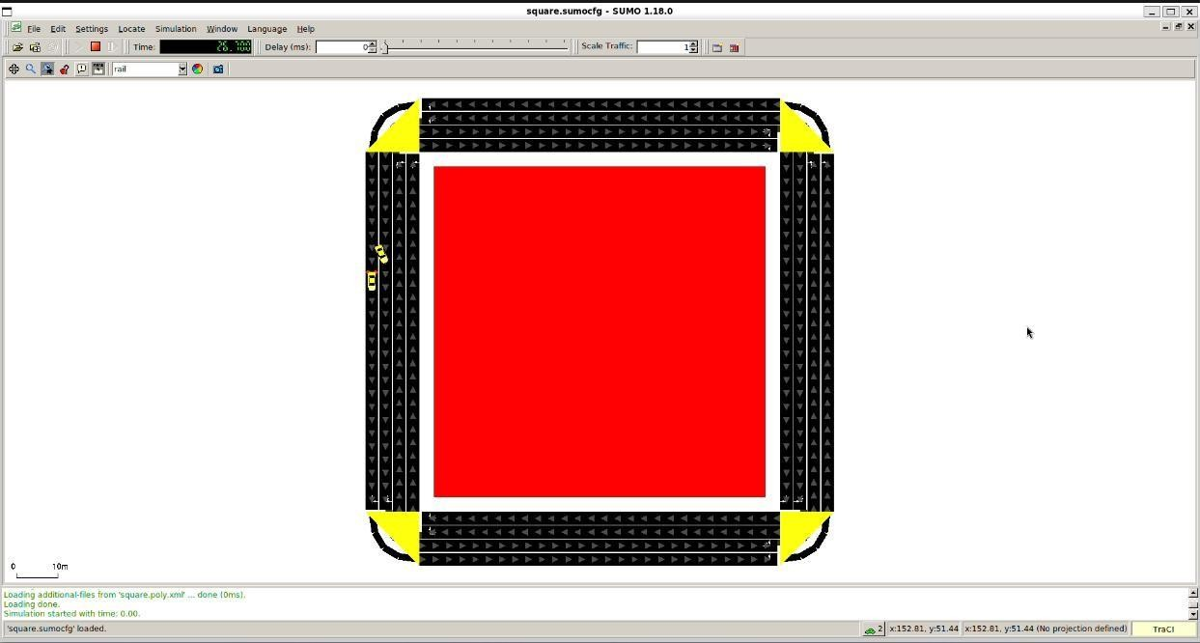

Fig 7.7.2 Collision Avoidance Warn drivers if another vehicle is approaching at high speed. Alert if a vehicle suddenly brakes

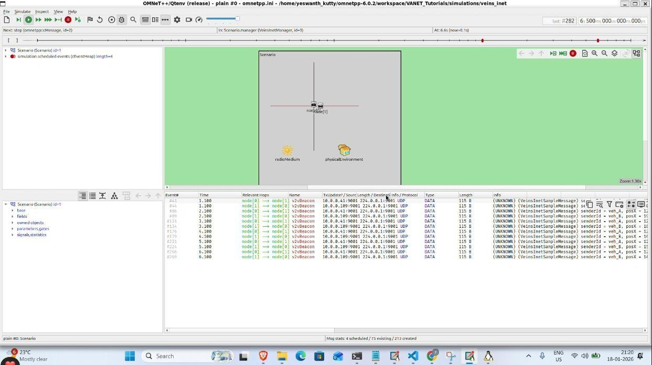

Fig 7.7.3 Intersection Safety Avoids Crashes at Junctions even when visibility is limited

CHAPTER 8 DISCUSSION

This chapter discusses the performance and significance of the developed autonomous vehicle system. The system was designed to demonstrate how vehicles can communicate with each other and make cooperative decisions to avoid collisions. The discussion focuses on interpreting the experimental results, evaluating the system’s practical importance, and identifying possible limitations and improvements.

The results obtained from the testing scenarios show that the integration of sensors, wireless communication, and embedded control algorithms can successfully enable vehicles to coordinate their movement in different traffic situations[19,21].

Interpretation of Results

The experimental results indicate that the proposed system successfully implemented Vehicle-to-Vehicle communication and cooperative decision making. The ESP32 microcontroller effectively processed sensor inputs and communication data to determine vehicle actions. During testing, vehicles were able to detect nearby vehicles using ultrasonic sensors and exchange information using Bluetooth communication.

Based on the decision algorithm, vehicles adjusted their movement by slowing down, stopping, or continuing forward. The results demonstrate that the system can successfully perform basic autonomous decision-making tasks.

Significance

The proposed system demonstrates the practical application of embedded systems and wireless communication in intelligent transportation technologies. By enabling vehicles to communicate and cooperate, the system reduces the chances of collisions and improves overall traffic safety. The use of the ESP32 microcontroller with built-in Bluetooth communication provides a low-cost and efficient platform for implementing Vehicle-to-Vehicle communication. The system also demonstrates how simple rule-based algorithms can be used to achieve effective collision avoidance in small-scale autonomous vehicle models.

Comparison with Baseline
The developed system was compared with a baseline scenario where vehicles operate without communication or coordination. In the baseline case, vehicles rely only on manual control or basic obstacle detection, which can lead to delayed reactions and possible collisions. In contrast, the proposed system uses ESP32- based Bluetooth communication and sensor data to enable vehicles to exchange information and coordinate their movement.

Practical Relevance

- The concepts demonstrated in this project have practical relevance in real- world transportation systems. Modern intelligent transportation systems rely on communication between vehicles to improve safety and traffic efficiency.
- The project illustrates how vehicles can share information and make decisions collectively rather than operating independently. Such systems can be extended to
- larger vehicle networks where communication and coordination play a critical role in preventing accidents.
- Although this project is implemented using miniature vehicles, the underlying

principles are similar to those used in real autonomous vehicle technologies.[7,21]

Limitations

Despite the successful operation of the system, there are certain limitations that must be considered. The communication range of Bluetooth is limited compared to other wireless communication technologies used in real autonomous vehicle systems. The system also relies on simple rule-based decision algorithms, which may not handle highly complex traffic situations. Additionally, the testing environment was controlled and may not fully represent real-world traffic conditions.

These limitations indicate areas where further improvements can be made in future research.

Future Work Recommendations

Future work can focus on improving the system by integrating additional sensors and advanced decision-making algorithms. Technologies such as camera- based vision systems or LiDAR sensors could enhance environmental perception.

The communication system could also be upgraded to support longer communication ranges and faster data exchange. Implementing artificial intelligence or machine learning techniques may allow vehicles to make more advanced decisions in complex traffic scenarios.

These improvements could expand the capabilities of the system and make it more suitable for real-world autonomous transportation application.[19]

CHAPTER 9

CONCLUSION

Key Outcomes

The project successfully achieved the objectives of designing and implementing a miniature autonomous vehicle system capable of cooperative decision-making. The ESP32 microcontroller effectively managed sensor inputs, Bluetooth communication, and motor control. The system demonstrated reliable performance in three different scenarios: vehicles moving in opposite directions, vehicles moving in the same direction, and vehicles approaching an intersection from perpendicular directions. In each scenario, the vehicles were able to communicate and adjust their movement to avoid collisions.

Advantages
- The proposed system offers several advantages. The use of the ESP32 microcontroller provides an integrated platform with built-in Bluetooth communication, reducing hardware complexity. The system uses simple sensors and rule-based algorithms, making it cost-effective and easy to implement.
- The modular design allows the system to be expanded or modified for future research. The project also provides a practical demonstration of how communication between vehicles can improve safety and coordination.
- Overall, the system demonstrates the feasibility of implementing cooperative autonomous vehicle behavior using compact embedded systems.

Future Scope

- Although the system successfully demonstrates basic Vehicle-to-Vehicle communication and collision avoidance, there are several opportunities for further improvement.
- Future developments could include integrating additional sensors such as cameras or LiDAR to improve environmental perception. The communication system could also be enhanced using more advanced wireless technologies with greater range and reliability.
- More advanced decision-making algorithms, including artificial intelligence and machine learning techniques, could be implemented to handle more complex traffic scenarios. These improvements could extend the capabilities of the system and make it more suitable for real-world intelligent transportation applications.

Concluding Remarks

The project successfully demonstrates a miniature autonomous vehicle system capable of communication and cooperative decision-making. By combining sensing, Bluetooth communication, and embedded control, the system provides a practical model for studying intelligent transportation technologies.

The results highlight the importance of Vehicle-to-Vehicle communication in improving traffic safety and coordination. The project serves as a foundation for further research in autonomous systems, embedded communication networks, and smart mobility solutions.

APPENDIX

Appendix A: Hardware Components and Specifications

The mini autonomous vehicle system is built using compact and cost-effective
embedded components. The primary hardware used in the system includes:
• ESP32 Microcontroller
Acts as the central processing unit. It handles sensor data processing, Bluetooth communication, and execution of the decision-making algorithm.
• Ultrasonic Sensor (HC-SR04)
Used for distance measurement and obstacle detection.
• Range: 2 cm – 400 cm
• Accuracy: ±3 mm
• Motor Driver Module (L298N)
Controls direction and speed of DC motors using PWM signals.
• DC Motors and Chassis
Provide motion and structural support for the vehicle.
• Power Supply Unit
Supplies required voltage for the entire system.

Appendix B: Algorithm Flow (Simplified)

The system follows a continuous loop-based embedded control logic:
1. Initialize ESP32, sensors, and Bluetooth module
2. Measure distance using ultrasonic sensor
3. Transmit vehicle data (ID, distance, status)
4. Receive data from nearby vehicles
5. Process data using decision algorithm
6. Apply rules:
    - If obstacle detected → Stop / Slow down
    - If path is clear → Move forward
    - At intersection → Apply priority rule
7. Send control signals to motor driver
8. Repeat continuously

Appendix C: Communication Data Format
Field | Description | Example
Vehicle ID | Unique identifier | 1
Direction | Movement direction | Forward
Distance | Measured distance | 20 cm
Status | Vehicle state | Moving

Appendix D: Test Scenarios Summary

The system was evaluated using three real-time scenarios:
1. Opposite Direction Movement
Vehicles detect each other and stop to avoid collision.
2. Same Direction Movement
Rear vehicle maintains safe distance by adjusting speed.
3. Intersection Scenario
Vehicles communicate and decide priority for safe crossing.

Appendix E: Simulation Tools

The project uses simulation tools to validate performance:
• OMNeT++ – Network simulation
• SUMO (Simulation of Urban Mobility) – Traffic simulation
• VEINS Framework – Integration of communication and mobility

These tools help analyze vehicle behavior, communication efficiency, and collision avoidance performance.

Appendix F: Key Advantages of System
• Low-cost implementation using ESP32
• Real-time vehicle communication
• Simple and effective decision-making algorithm
• Scalable for future improvements
• Demonstrates core concepts of intelligent transportation systems

REFERENCES

- Raj Kamal, Embedded Systems: Architecture, Programming and Design, McGraw Hill Education.
- Muhammad Ali Mazidi, ESP32 Microcontroller and Embedded Systems, Pearson Education.
- Tom Igoe, Making Things Talk: Using Sensors, Networks, and Arduino to See, Hear, and Feel Your World, O’Reilly Media.
- Kenney, J. B., “Dedicated Short-Range Communications (DSRC) Standards in the United States,” Proceedings of the IEEE, 2011.
- Hartenstein, H., and Laberteaux, K., “A Tutorial Survey on Vehicular Ad Hoc Networks,” IEEE Communications Magazine, 2008.
- Sommer, C., and Dressler, F., Vehicular Networking, Cambridge University Press, 2015.
- World Health Organization (WHO), Global Status Report on Road Safety, World Health Organization, Geneva, 2023. Available: https://www.who.int
- National Crime Records Bureau (NCRB), Accidental Deaths and Suicides in India 2022, Ministry of Home Affairs, Government of India, New Delhi, 2023. Available: https://ncrb.gov.in
- Sommer, C., German, R., and Dressler, F., “Bidirectionally Coupled Network and Road Traffic Simulation for Improved Inter-Vehicle Communication Analysis,” IEEE Transactions on Mobile Computing, Vol. 10, No. 1, pp. 3– 15, 2011.
- Krawer, D., Erdogon, J., Behrisch, M., and Bieker, L., “Recent Development and Applications of SUMO – Simulation of Urban Mobility,” International Journal on Advances in Systems and Measurements, Vol. 5, No.
- Varga, A., and Hormer, R., “An Overview of the OMNeT++ Simulation Environment,” Proceedings of the European Simulation Multiconference, 2008.
- Hartenstein, H., and Laberteaux, K., “A Tutorial Survey on Vehicular Ad Hoc Networks,” IEEE Communications Magazine, Vol. 46, No. 6, pp. 164–171, 2008.
- Lee, J., and Gerland, M., “A Survey of Sensing and Decision- Making Technologies for Intelligent Transportation Systems,” IEEE Communications Surveys & Tutorials, Vol. 22, No. 1, pp. 653–681, 2020.
- Arduino, “Arduino UNO R3 – Technical Documentation and Datasheet,” Arduino Official Documentation, 2023. Available: https:
- · Kenney, J. B., “Dedicated Short-Range Communications (DSRC) Standards in the United States,” Proceedings of the IEEE, Vol. 99, No. 7, pp. 1162–1182, 2011.
- · Campolo, C., Molinaro, A., and Scopigno, R., “From Today's VANETs to Tomorrow's Planning and the IoT,” Vehicular Communications, Vol. 2, No. 3, pp. 158–171, 2015.
- · Olaverri-Monreal, C., “Autonomous Vehicles and Smart Mobility Related Technologies,” Transportation Research Procedia, Vol. 14, pp. 17– 26, 2016.
- · Rajamani, R., Vehicle Dynamics and Control, Springer, New York, 2012.
- · Thrun, S., Burgard, W., and Fox, D., Probabilistic Robotics, MIT Press, Cambridge, 2005.
- · Siegwart, R., Nourbakhsh, I., and Scaramuzza, D., Introduction to Autonomous Mobile Robots, MIT Press, Cambridge, 2011.
- · Valvano, J. W., Embedded Systems: Real-Time Interfacing to Arm Cortex-M Microcontrollers, CreateSpace Publishing, 2019.

- · Kurniawan, A., Internet of Things Projects with ESP32, Packt Publishing, Birmingham, 2019.
- · Monk, S., Programming Arduino: Getting Started with Sketches, McGraw-Hill Education, New York, 2016.
- · Yick, J., Mukherjee, B., and Ghosal, D., “Wireless Sensor Network Survey,” Computer Networks, Vol. 52, No. 12, pp. 2292–2330, 2008.
- · Borenstein, J., Everett, H. R., and Feng, L., Where Am I? Sensors and Methods for Mobile Robot Positioning, University of Michigan Press, 1996.
- · Siciliano, B., and Khatib, O., Springer Handbook of Robotics, Springer, Berlin, 2016.
- · · Chen, L., Englund, C., “Cooperative Intersection Management: A Survey,” IEEE Transactions on Intelligent Transportation Systems, Vol. 17, No. 2, pp. 570–586, 2016.
- · · Sommer, C., and Dressler, F., Vehicular Networking, Cambridge University Press, Cambridge, 2015.
- · Darwish, A., and Hassanien, A. E., “Wearable and Implantable Wireless Sensor Network Solutions for Healthcare Monitoring,” Sensors, Vol. 11, No. 6, pp. 5561–5595, 2011.
- · Redmon, J., and Farhadi, A., “YOLOv3: An Incremental Improvement,” arXiv preprint arXiv:1804.02767, 2018.
- · Espressif Systems, “ESP32 Technical Reference Manual,” Espressif Systems Documentation, 2023. Available: https://www.espressif.com
- · Espressif Systems, “ESP32-WROOM-32 Datasheet,” Espressif Systems Documentation, 2023.
- · Texas Instruments, “L298N Dual H-Bridge Motor Driver Datasheet,” Texas Instruments, 2022.
- · MaxBotix Inc., “Ultrasonic Distance Sensor Datasheet and Application Guide,” MaxBotix Documentation, 2022.

PO & PSO ATTAINMENT

PO.No | Graduate Attribute | Attained | Justification
PO 1 | Engineering knowledge | Yes | Applied embedded systems, electronics, and communication concepts
PO 2 | Problem analysis | Yes | Intersection collision risk was clearly analyzed and addressed.
PO 3 | Design/Development of solutions | Yes | Designed a complete autonomous V2V system solution.
PO 4 | Conduct investigations of complex problems | Yes | Used simulation and real testing for system evaluation.
PO 5 | Modern Tool Usage | Yes | Used Arduino, VEINS, OMNeT++, SUMO, and wireless tools.
PO 6 | The Engineer and society | Yes | Contributes to public safety and accident prevention.
PO 7 | Environment and Sustainability | Yes | Used low-power and energy efficient components.

PO 8 | Ethics | Yes | Focused on safety, reliability, and responsible automation..
PO 9 | Individual and teamwork | Yes | Achieved through teamwork and collaboration.
PO 10 | Communication | Yes | Effectively documented architecture design, performance results, and comparative analysis through technical reports, presentation slides, and graphical results.
PO 11 | Project management and finance | Yes | Completed within cost and time constraints
PO 12 | Life-long learning | Yes | Encouraged continuous learning in autonomous systems.

PSO.No | Graduate Attribute | Attained | Justification
 | To analyze, design, and
 | develop electronic and |  | The project applies electronics,
 | intelligent systems using |  | embedded systems, control
PSO 1 | core concepts | YES | systems, and communication
 | of |  | principles to build an autonomous
 | Electronics and |  | vehicle system.
 | Communication
 | Engineering.
 | To create innovative |  | The system integrates embedded systems, wireless communication, simulation modeling, and intelligent decision-making for sustainable smart mobility solutions..
 | solutions for real-world
 | Considerations by
PSO 2 | adapting modern tools, | YES
 | automation technologies,
 | and interdisciplinary
 | approaches.

